AWS VPC Lab Experience
I recently completed a Udemy lab where I set up a custom AWS Virtual Private Cloud (VPC) to support EC2 deployments. The goal was to create a secure and scalable network by designing public and private subnets, configuring route tables, and launching instances. Even though this was a guided lab, I made a point to attempt each step on my own first before checking the instructions.
Getting Started
Before jumping into the lab, I grabbed some scratch paper and sketched out what I thought the VPC should look like. I mapped out the subnets, estimated CIDR ranges, and planned how traffic would flow between resources. This helped me visualize the architecture before actually building it in AWS. Overall, the sketch out worked out really well as I went through the lab.

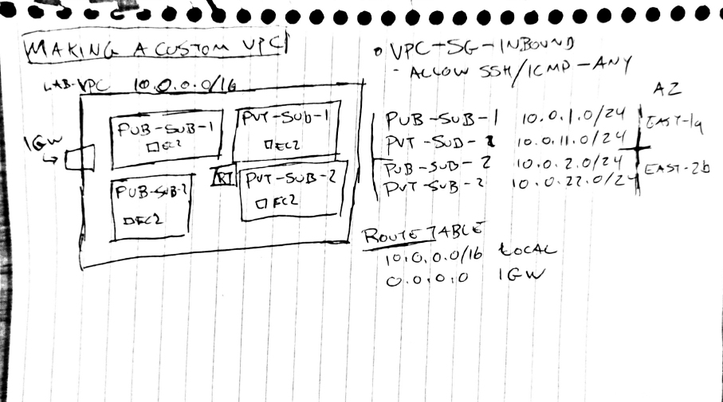

Steps I Took
- Created the VPC – I defined an IPv4 CIDR block and set up the initial network structure.
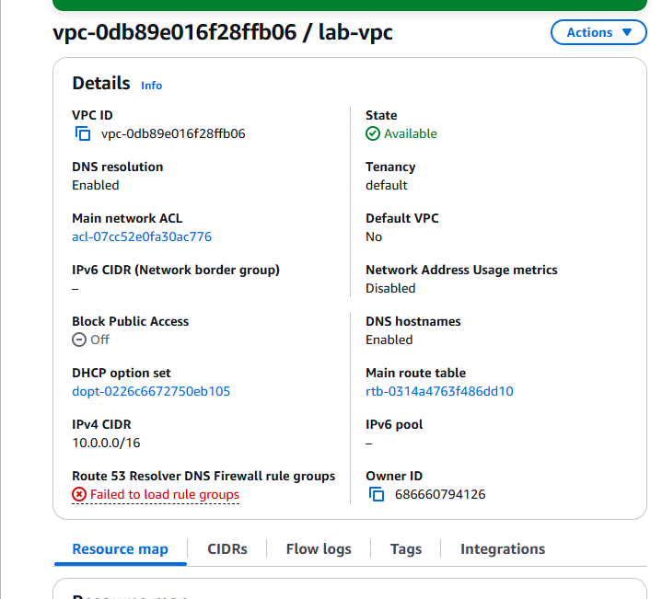

- Added Public & Private Subnets – I made sure the public subnet had auto-assigned public IPs while keeping the private one isolated.
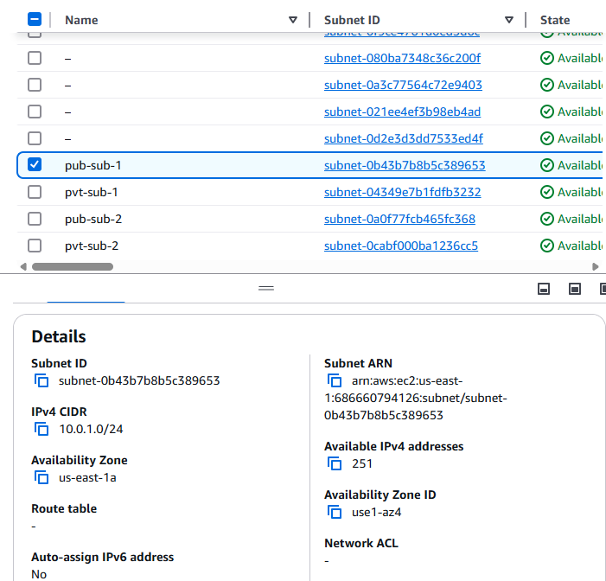

- Configured Route Tables – The public subnet got a route to an Internet Gateway, while the private subnet’s routing was restricted for security.
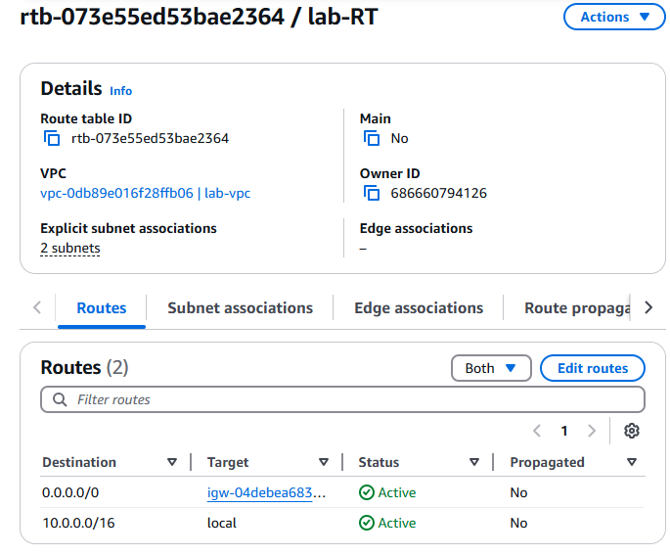

- Launched EC2 Instances – I deployed instances in both subnets and tested network connectivity between them.
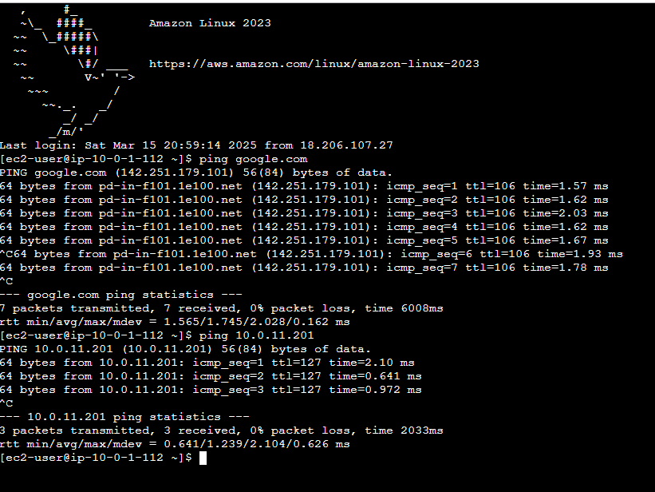
- Following best cloud practices, I ensured that I cleaned up after myself to avoid any unwanted charges for services no longer needed.
Key Takeaways
- Sketching out the network beforehand helped me better understand subnetting and CIDR allocations.
- Trying to complete each step without immediately checking the walkthrough made me think critically about AWS networking.
- This lab reinforced how cloud infrastructure is the backbone of cloud security—without a solid network setup, securing cloud environments would be impossible.
Overall, this was a great hands-on experience that strengthened my understanding of AWS networking. It’s another step forward in my cloud security journey! Onward to AWS Solutions Architect!

